

Data Base Project

Laptop selling store website

Pacuraru Fabian | Data Bases | 28.05.2021

# What was it made for?

This project aims to simulate a website that is connected to a database that could be used to see and manage the specifications, prices and stocks of laptops that a store or multiple stores might sell.

I worked just a little on the styling part so the project may seem not suitable for actual use, but the most important part, in my opinion, is that all the elements work as intended and for a first project using html, css and php, I am happy with its functionality.

# Tables

I started this project by creating 8 tables for the actual website and one for the login page. Then indexes must be created in order to be able to link the tables to one another. I also added a constraint of type UNIQUE on the field Username from table login, which is going to prevent storing multiple accounts with the same username.

## main

“CREATE TABLE main (

Laptop_Id int(255) NOT NULL,

Display_Id int(255) NOT NULL,

Processor_Id int(255) NOT NULL,

Ram_Id int(255) NOT NULL,

Storage_Id int(255) NOT NULL,

Graphics_Card_Id int(255) NOT NULL

);”

“CREATE INDEX Laptop_Id

ON main (Laptop_Id);”

“CREATE INDEX Display_Id

ON main (Display_Id);”

“CREATE INDEX Processor_Id

ON main (Processor_Id);”

“CREATE INDEX Ram_Id

ON main (Ram_Id);”

“CREATE INDEX Storage_Id

ON main (Storage_Id);”

“CREATE INDEX Graphics_Card_Id

ON main (Graphics_Card_Id);”

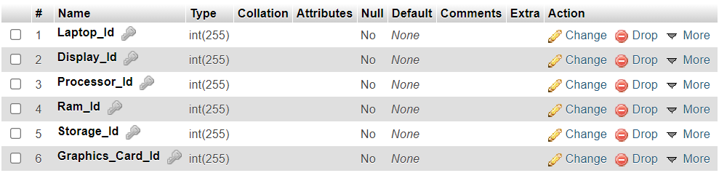

## laptop

“CREATE TABLE laptop (

Id_l int(255) NOT NULL AUTO_INCREMENT PRIMARY KEY,

Model_l varchar(50),

Width_l float,

Height_l float,

Depth_l float,

Weigth_l float,

Availability_Id int(255)

);”

“CREATE INDEX Availability_Id

ON laptop (Availability_Id);”

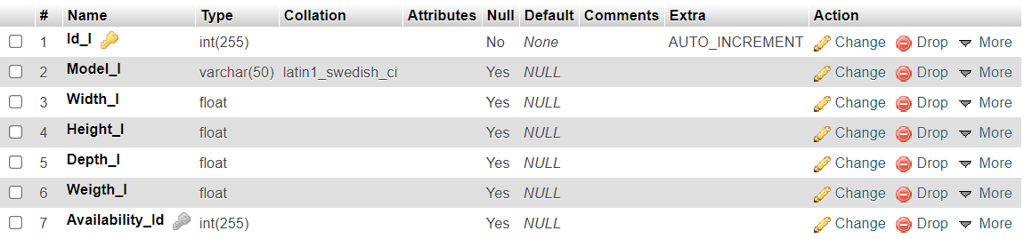

## processor

“CREATE TABLE processor (

Id_p int(255) NOT NULL AUTO_INCREMENT PRIMARY KEY,

Model_p varchar(50),

Core_Count_p int(255),

Nominal_Frequency_p float,

Turbo_Frequency _p float,

Cache_p varchar(50),

Technology_p varchar(50)

);”

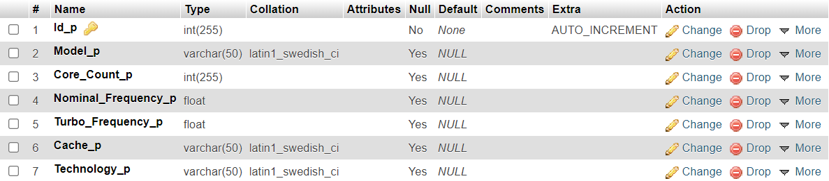

## ram

“CREATE TABLE ram (

Id_r int(255) NOT NULL AUTO_INCREMENT PRIMARY KEY,

Capacity_r int(255),

Technology_r varchar(50),

Frequency_r float

);”

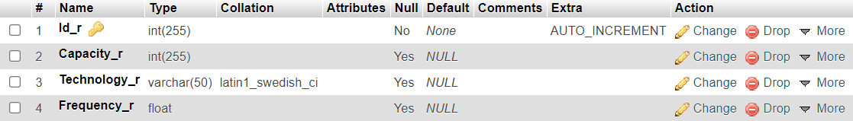

## storage

“CREATE TABLE storage (

Id_s int(255) NOT NULL AUTO_INCREMENT PRIMARY KEY,

Type_s varchar(50),

Capacity_s varchar(50),

Interface_s varchar(50)

);”

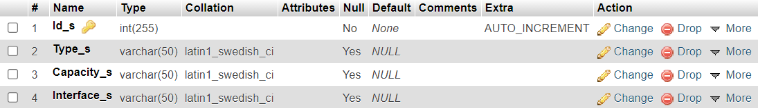

## display

“CREATE TABLE display (

Id_d int(255) NOT NULL AUTO_INCREMENT PRIMARY KEY,

Diagonal_d float,

Luminosity_d int(255),

Resolution_d varchar(50),

Format_d varchar(50)

);”

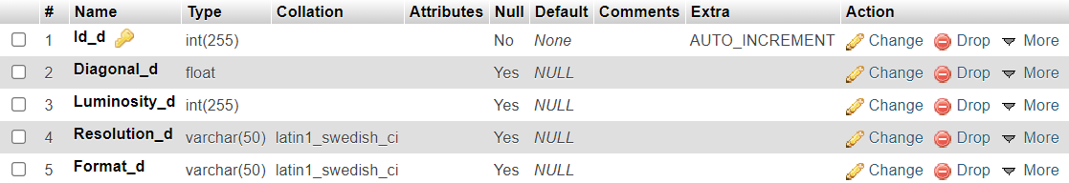

## graphics card

“CREATE TABLE graphics_card (

Id_g int(255) NOT NULL AUTO_INCREMENT PRIMARY KEY,

Type_g varchar(50),

Model_g varchar(50),

Capacity_g int(255),

Technology_g varchar(50)

);”

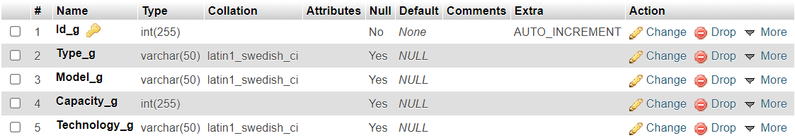

## availability

“CREATE TABLE availability (

Id int(255),

Store_name varchar(50),

Deposit_Id int(255),

Price float,

Stock int(255),

Bigger_Deposit_Id int(255)

);”

“CREATE INDEX Id

ON availability (Id);”

“CREATE INDEX Deposit_Id

ON availability (Deposit_Id);”

“CREATE INDEX Bigger_Deposit_Id

ON availability (Bigger_Deposit_Id);”

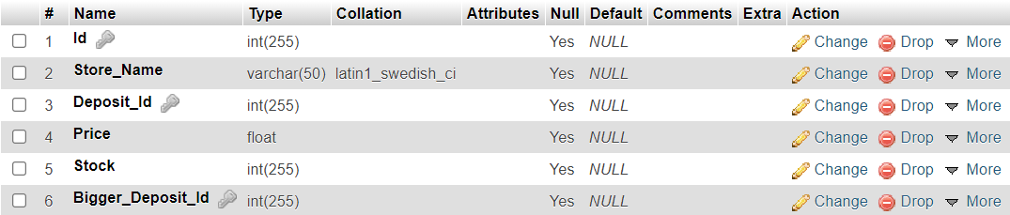

## login

“CREATE TABLE login (

Username varchar(50) NOT NULL,

Password varchar(50) NOT NULL,

Admin tinyint

);”

“ALTER TABLE login

ADD CONSTRAINT Username UNIQUE (Username);”

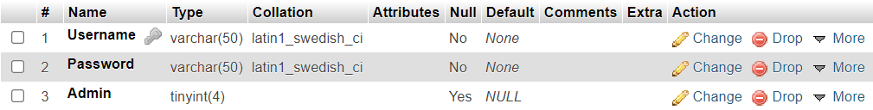

# Relationships between tables

I used phpMyAdmin designer and I created multiple relationships between tables as you can see in the next picture.

I used three types of relationships:

1. One to many
2. Many to many
3. Recursive

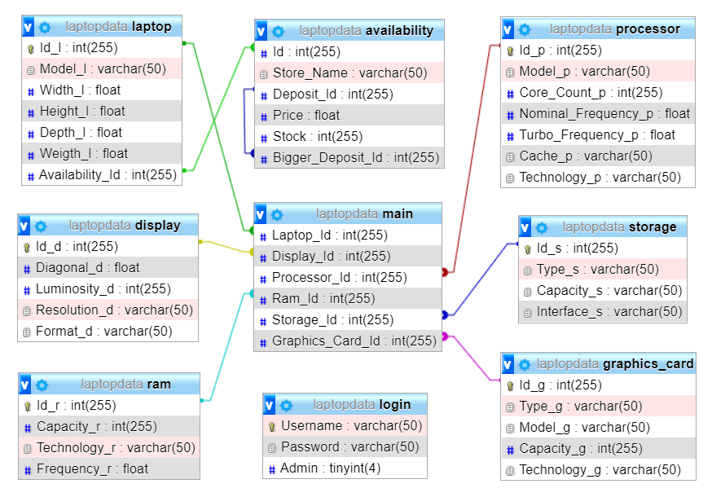

## One to many relationships

* From table laptop to table main with Id_l = Laptop_Id
* From table processor to table main with Id_p = Processor_Id
* From table ram to table main with Id_r = Ram_Id
* From table storage to table main with Id_s = Storage_Id
* From table display to table main with Id_d = Display_Id
* From table graphics_card to table main with Id_g = Graphics_Card_Id

## Many to many relationships

* From table laptop to table availability with Availability_Id = Id

## Recursive relationships

* Into table availability with Deposit_Id = Bigger_ Deposit_Id

# Views

I created 4 views using some JOIN statements, some aggregate functions. I also ordered and grouped my results using ORDER BY, GROUP BY and LIMIT instead of TOP.

## First View

”CREATE VIEW view1 AS SELECT Model_l,Width_l,Height_l,Depth_l,Weigth_l,Model_p,Core_Count_p,Nominal_Frequency_p,Turbo_Frequency_p,Cache_p,Technology_p,Capacity_r,Technology_r,Frequency_r,Type_s,Capacity_s,Interface_s,Diagonal_d,Luminosity_d,Resolution_d,Format_d,Type_g,Model_g,Capacity_g,Technology_g FROM ((((((main JOIN laptop ON Laptop_Id = Id_l) JOIN display ON Display_Id=Id_d) JOIN processor ON Processor_Id=Id_p) JOIN ram ON Ram_Id=Id_r) JOIN storage ON Storage_Id=Id_s) JOIN graphics_card ON Graphics_Card_Id=Id_g)”





## Second View

“CREATE VIEW view2 AS SELECT Model_l, SUM(Stock) AS Total_Stock FROM laptop JOIN availability ON Availability_Id=Id GROUP BY Model_l”

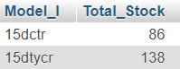

## Third View

“CREATE VIEW view3 AS SELECT Model_l, COUNT(*) AS Store_that_has FROM laptop JOIN availability ON Availability_Id=Id GROUP BY Model_l ORDER BY Store_that_has DESC LIMIT 5”

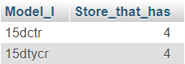

## Fourth View

“CREATE VIEW view4 AS SELECT X.Store_Name AS small_store, Y.Store_Name AS big_store FROM availability X JOIN availability Y on X.Bigger_Deposit_Id=Y.Deposit_Id WHERE X.Deposit_Id!=Y.Deposit_Id GROUP BY small_store, big_store”

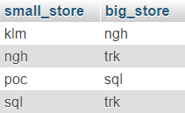

# How to use?

It is true that this website is not too pleasant to the eye, but it is quite simple to use in my opinion. All the actions that can be done into the main webpage, that was split between two sections, can be selected from the left section of the webpage. This is true for both admins and regular users, even though the admins will have much more options.

The users can see the first three views and the select option that will show them exactly what they want from the database, while the admins can see all four views, can select from, insert into, update and delete from the database, regarding first 7 tables. The admins can also add, modify or delete the login table that stores the credentials and whether or not that is a user or an admin and they can also modify the price and stock of products in different stores that are already in the database.

This is how the menu looks like for admins vs users:

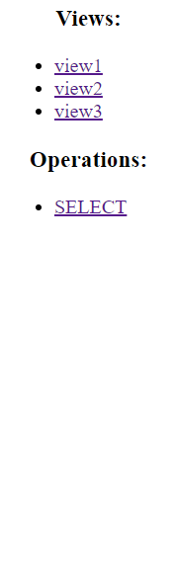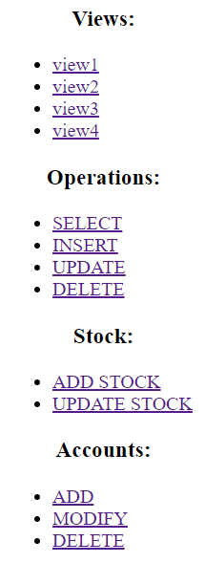 admin: regular user: